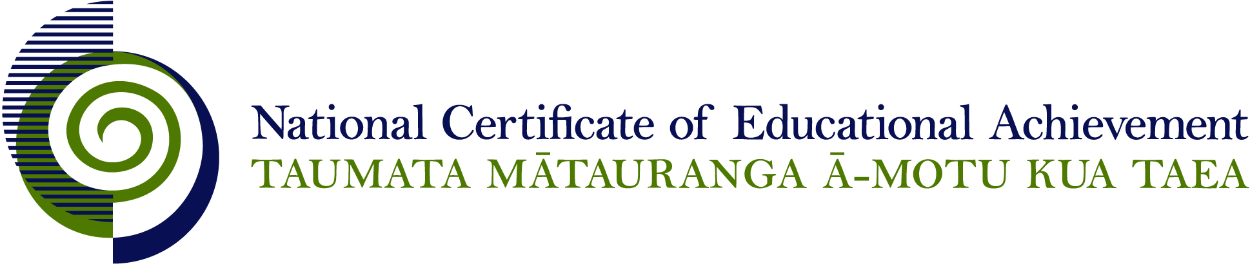

NCEA Level 3 Home Economics

Conditions of Assessment

General Information

Subject Reference | Home Economics
Domain | Home Economics
Level | 3
________________________________________________________________________

NB: It is expected that teachers are familiar with additional generic guidance on This document provides guidelines for assessment against internally assessed standards. Guidance is provided on:
- appropriate ways of, and conditions for, gathering evidence
- ensuring that evidence is authentic
- any other relevant advice specific to an achievement standard.

NB: It is expected that teachers are familiar with additional generic guidance on assessment practice in schools published on the NZQA website. This should be read in conjunction with these Conditions of Assessment.

For All Standards

Internal assessment provides considerable flexibility in the collection of evidence. Evidence can be collected in different ways to suit a range of teaching and learning styles and a range of contexts of teaching and learning. Care needs to be taken to allow students opportunities to present their best evidence against the standard(s) that are free from unnecessary constraints.

It is recommended that the design of assessment reflects and reinforces the ways students have been learning. Collection of evidence for the internally assessed standards could include, but is not restricted to, an extended task, an investigation, digital evidence (such as recorded interviews, blogs, photographs or film) or a portfolio of evidence.

It is also recommended that the collection of evidence for internally assessed standards should not use the same method that is used for any external standards in a programme/course, particularly if that method is using a time bound written examination. This could unfairly disadvantage students who do not perform well under these conditions.

A separate assessment event is not needed for each standard. Often assessment can be integrated into one activity that collects evidence towards two or three different standards from a programme of learning. Evidence can also be collected over time from a range of linked activities (for example, in a portfolio).This approach can also ease the assessment workload for both students and teachers.

Where all, or a significant part, of the evidence for assessment is presented orally, this will need to be recorded (audio or video) and annotated for in-school and national moderation purposes. Note that the judgement made about the quality of the work is not made on the quality of the ‘oral performance’ but the meaning inherent in the verbal presentation (or in the written notes students will likely prepare to support the presentation).

Effective assessment should suit the nature of the learning being assessed, provide opportunities to meet the diverse needs of all students and be valid and fair.

Where manageable, and after further learning has taken place, students may be offered a maximum of one further opportunity for assessment against an assessment standard within a year.

Authenticity of student evidence needs to be assured regardless of the method of collecting evidence. This needs to be in line with school policy. For example, for an investigation carried out over several sessions, this could include teacher observations or the use of milestones such as meetings with students, journal or photographic entries recording progress etc.

Regular discussions and checkpoints can be used to ensure that the evidence presented for assessment is authentic. This is important in the situation where students have collaborated to collect information from surveys, interviews or gather resources from documentaries, articles, and internet research. Where a group approach is used the teacher needs to ensure that there is evidence that each student has met all aspects of the standard.

Specific Information for Individual Internal Achievement Standards

Achievement Standard Number | 91466 Home Economics 3.1
Title | Investigate a nutritional issue affecting the well-being of New Zealand society
Number of Credits | 5
Version | 1

NB: It is important to read the section “For All Standards” at the start of this document.

Achievement Standard Number | 91467 Home Economics 3.2
Title | Implement an action plan to address a nutritional issue affecting the well-being of New Zealand society
Number of Credits | 5
Version | 1

NB: It is important to read the section “For All Standards” at the start of this document.

This assessment is to be completed during and after students have carried out an action plan to address a nutritional concern. The developing and implementing stages of the action plan is likely to be a group activity; however, the teacher needs to ensure authenticity of individual student contributions. The ongoing reflection and evaluation must be done individually. It is necessary to collect this evidence during the process.

Achievement Standard Number | 91468 Home Economics 3.3
Title | Analyse a food related ethical dilemma for New Zealand society
Number of Credits | 5
Version | 1

NB: It is important to read the section “For All Standards” at the start of this document.

Achievement Standard Number | 91469 Home Economics 3.4
Title | Investigate the influence of multinational food corporations on eating patterns in New Zealand
Number of Credits | 5
Version | 1

NB: It is important to read the section “For All Standards” at the start of this document.

